Lab Report No- 01
How to install Linux operating system

i) What is Linux Operating system?

Ans: Operating system is a set of programs that control the execution of application programs and act as an intermediary between a user of a computer and computer hardware.

ii) Different Type of Linux Distribution.

Ans: Today's Top 10 Linux Distributions are :

1.Ubuntu

2. Fedora

3. Linux Mint

4. openSUSE

5. PCLinuxOS

6. Debian

7. Mandriva

8. Sabayon/Gentoo

9. Arch Linux... plus Slackware

10. Puppy Linux... plus DSL

iii) How can we install Linux Operating System?

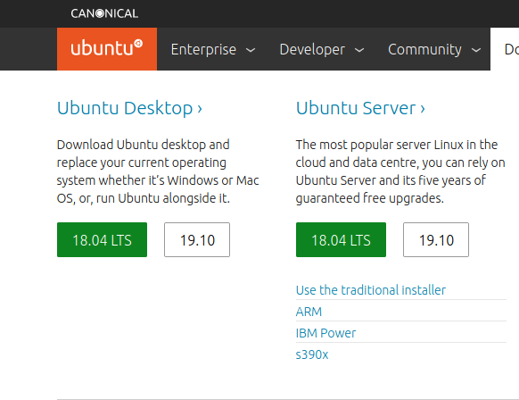
Step-1: Download the Ubuntu 18.04LST:

Step-2: Download Burn. Better for make a pendrive boot able :

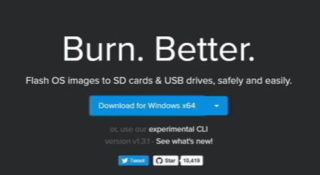

Step-3:Make some free space for Install of Ubuntu:

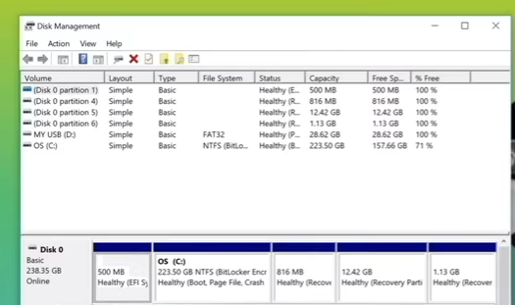

Step-4: Install Etcher:

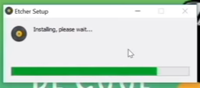

Step-5: Create live USB of Ubuntu with Etcher:

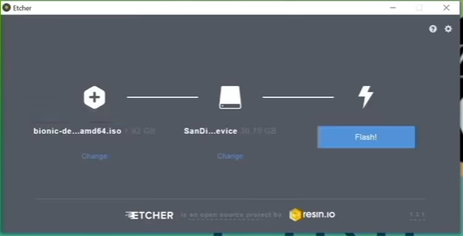
Step-6: Restarting :

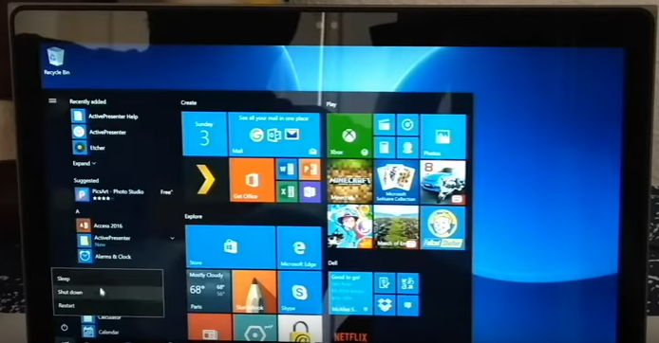
Step-7: Try Ubuntu without Installing:

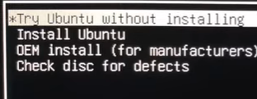

Step-8: Start Ubuntu installation:

keyboard layout ...
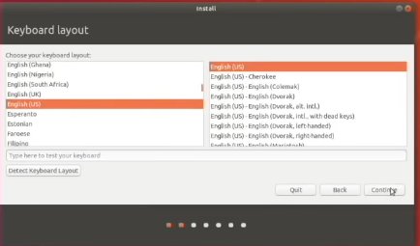

Step-9: Install Ubuntu Alongside windows Boot manager:

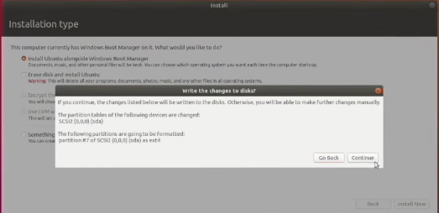

Step-10: Pretty straight forward from here:
where your area?
-Dhaka

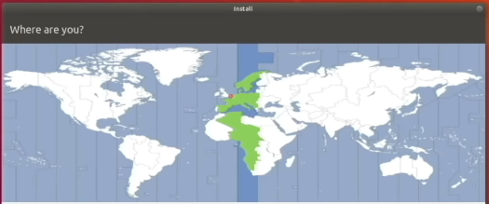

Step-11: Create your User and Password :

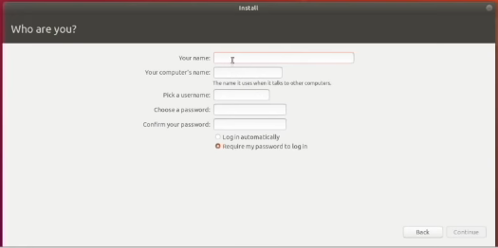

Step-12: After installing I will see that the grub screen with the option to Boot into Ubuntu and windows:

